

**NSBM Green University**

**In Partnership with Plymouth University** Faculty of Computing

**PUSL2024**

**Software Engineering 2**

Group Coursework

Coursework Specifications Report

Date of Submission: 31st of December 2023

|  |  |  |
| --- | --- | --- |
|  | **Group Number** | **B70** |
|  | **Student ID** | **Student Name** |
| 1 | 27809 | S P Welikada |
| 2 | 28074 | K V V H Gunarathna |
| 3 | 27114 | A M I S Senarathna |
| 4 | 28015 | A P H Abeysooriya |
| 5 | 26181 | UGS Abhishek |
| 6 | 27144 | I G S M Karunarathne |

## Table of Contents

1. Introduction…………………………………………………………….4
2. Identified Processes in GREEN Supermarket…………………………..4
3. Use Case Diagram………………………………………………….…..5
4. Class Diagram………………………………………………………….6
5. ER Diagram……………………………………………………………7
6. Contribution Sheet……………………………………………………11

**Introduction**

In the rapid evolution of technology, the global landscape experiences swift digitalization, permeating even the most basic activities and offering numerous benefits to individuals. GREEN Supermarket serves as a virtual shopping platform meticulously crafted to empower customers in effortlessly making their routine purchases from the comfort of their homes. This affords them the advantages of time efficiency and savings on travel expenses.



# 

# Identified Processes in GREEN Supermarket

GREEN Supermarket stands as a user-friendly web application meticulously crafted for the seamless procurement of customers' daily essentials. To ensure an enriched shopping experience, the platform undergoes regular updates, showcasing trending items, newly arrived products, and discounted offerings. Once an order is initiated, customers enjoy the convenience of real-time order tracking, allowing them to monitor its status effortlessly. The online payment process is facilitated through customers' PayPal accounts or direct bank transfers, prioritizing secure and hassle-free transactions. The website is designed to systematically capture and analyze all user interactions, providing valuable insights for managers to understand and cater to customer preferences effectively. Additionally, a dedicated feedback and review page empowers customers to share their thoughts, contributing to a dynamic and responsive shopping environment. Our communication strategy includes email notifications, initiated upon successful account creation, order placement confirmation, payment verification, and informing customers promptly in the event of order cancellation. This comprehensive approach aims to enhance the overall customer experience and foster a transparent and reliable online shopping platform.

# 

# iv. Use Case Diagram

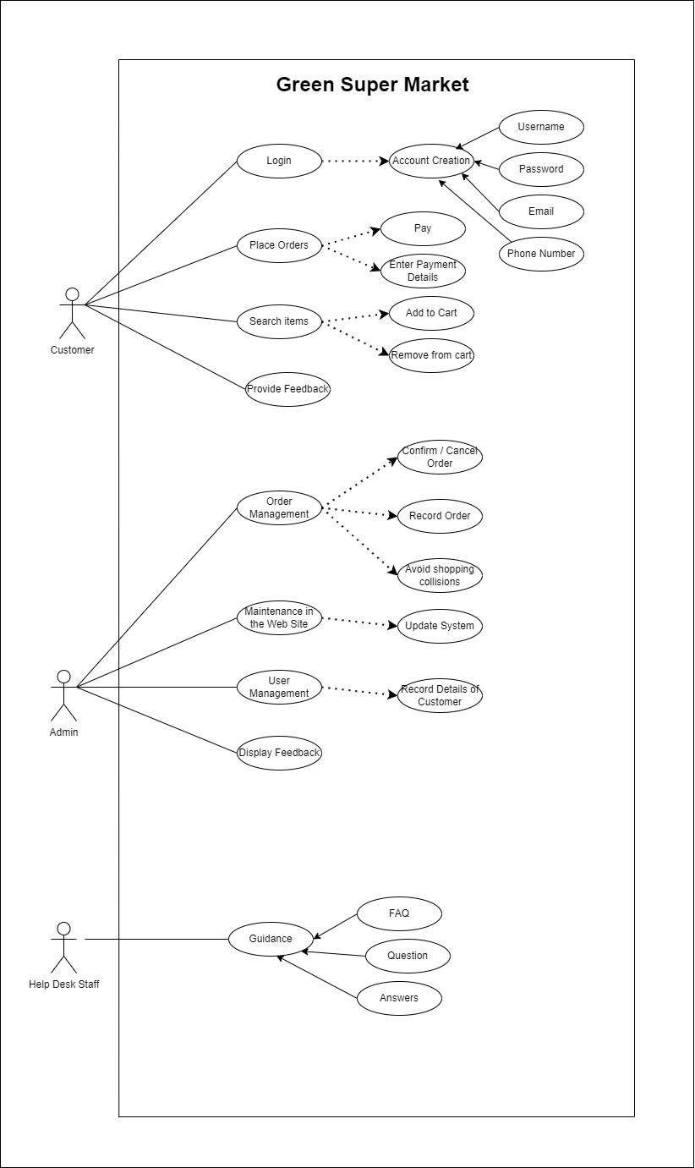

# v. Class Diagram

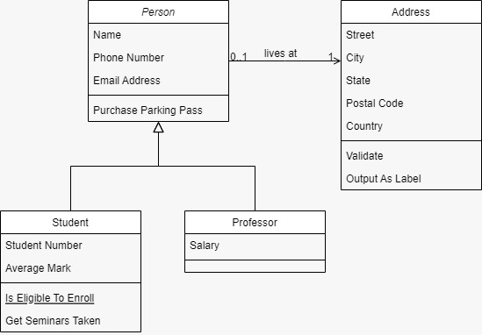

# vi. ER Diagram

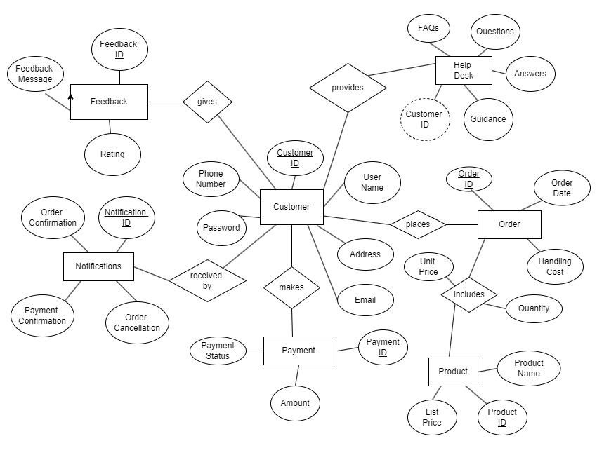

Product Categories

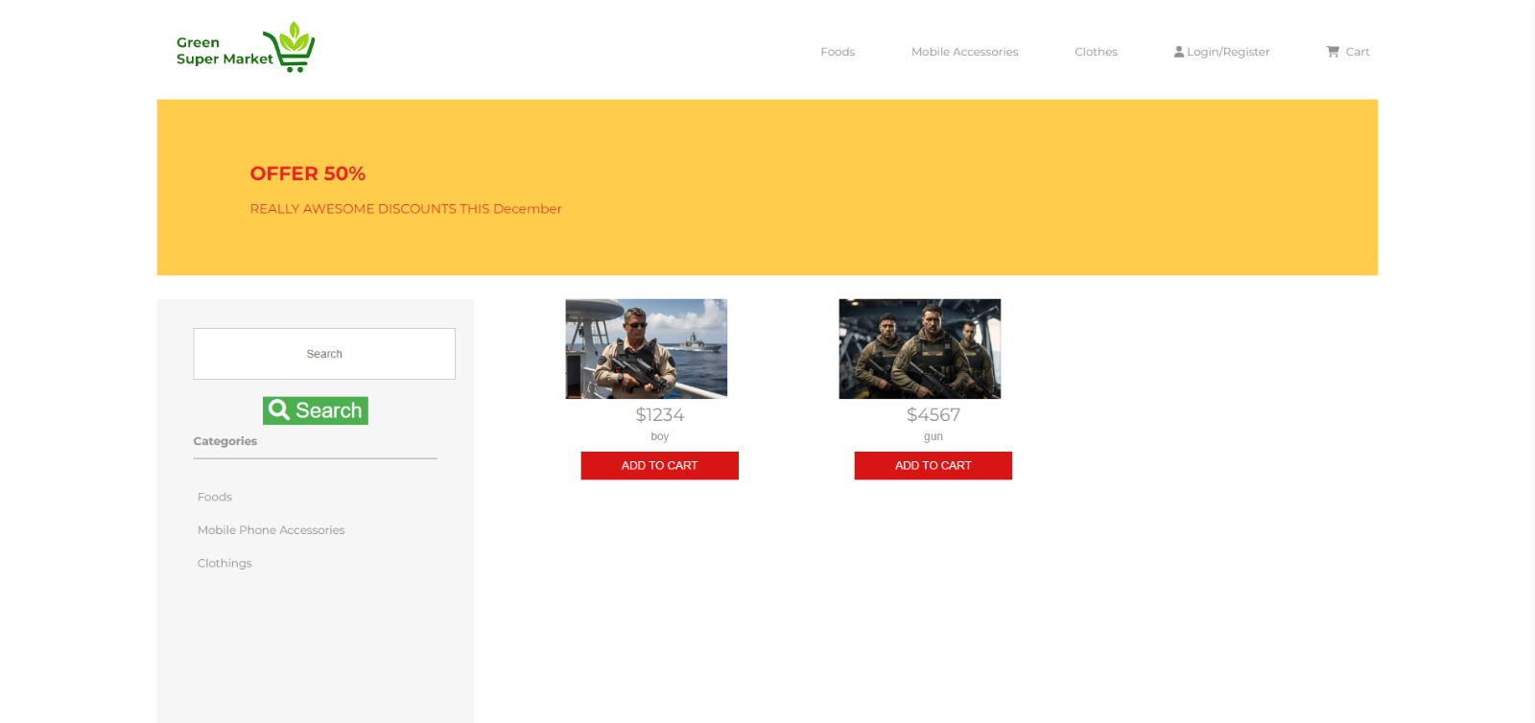

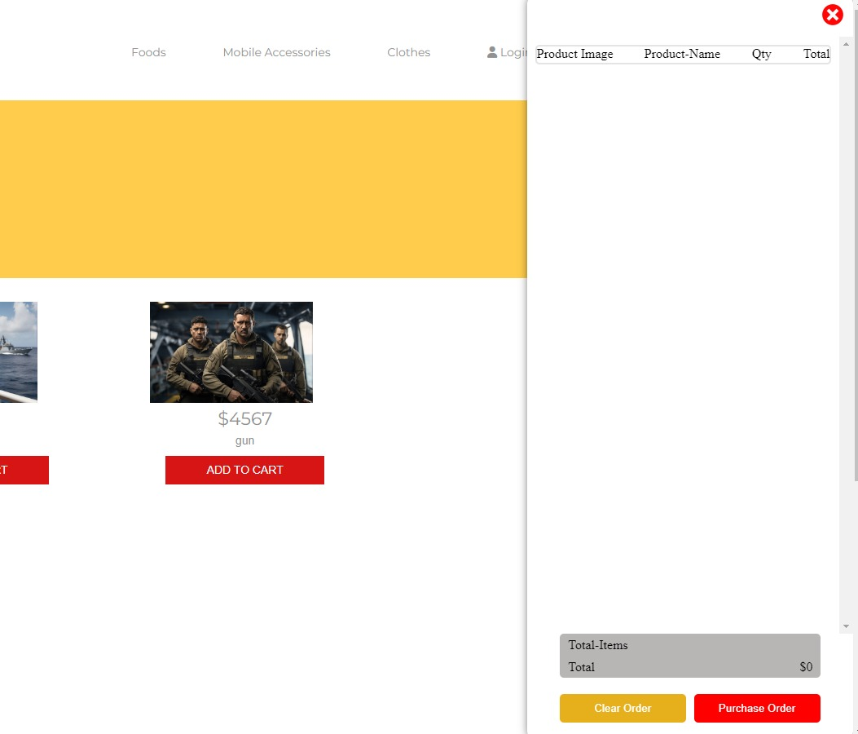Products and Prices

****Shopping Cart

### 

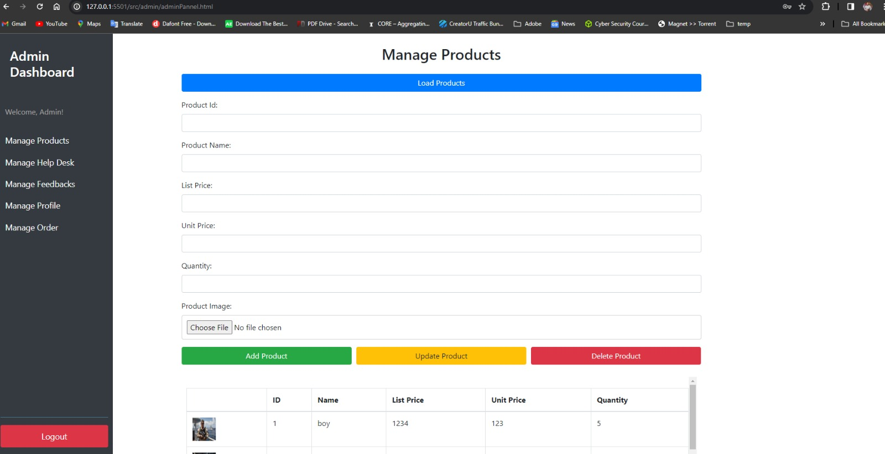

Admin panel

Order management section

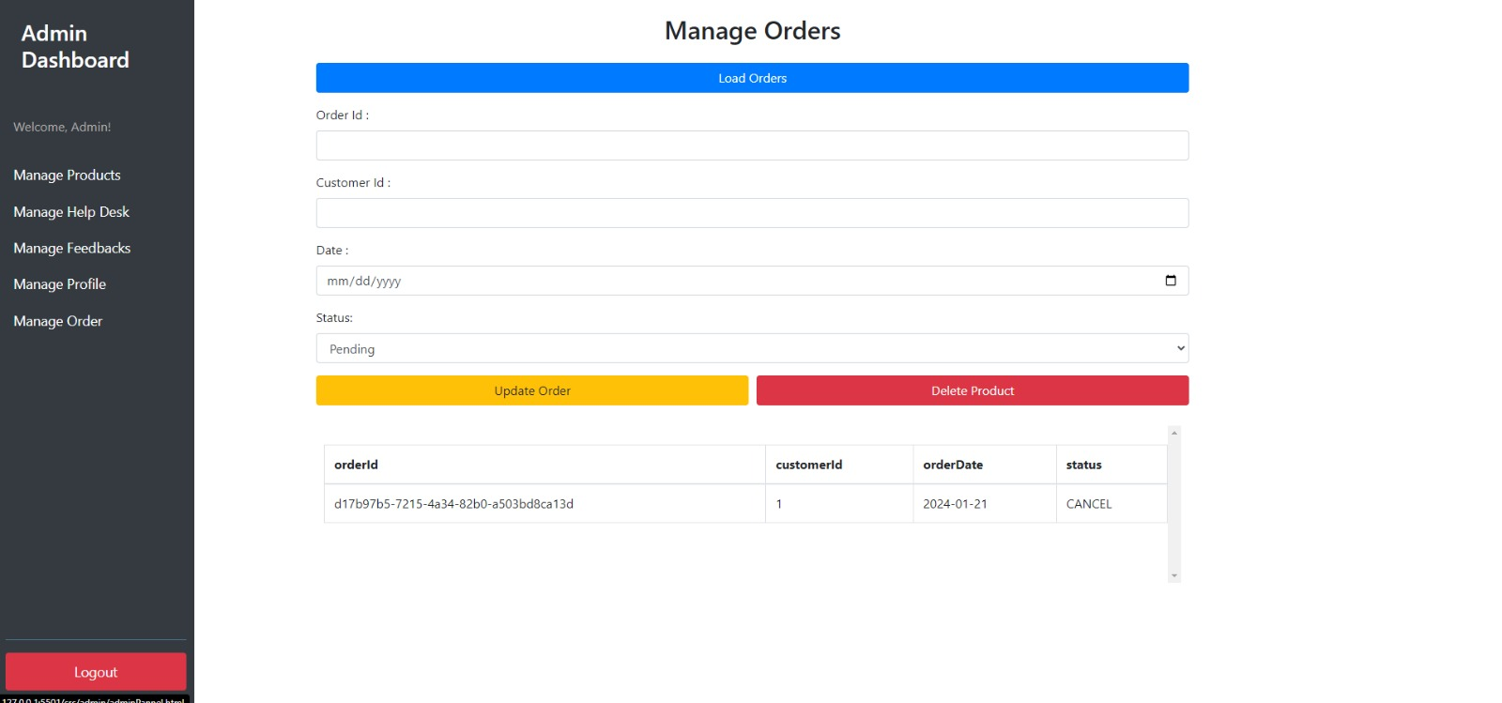

**GitHub link**

GitHub Link

https://github.com/SPWelikada/Green-Supermarket.git

# 

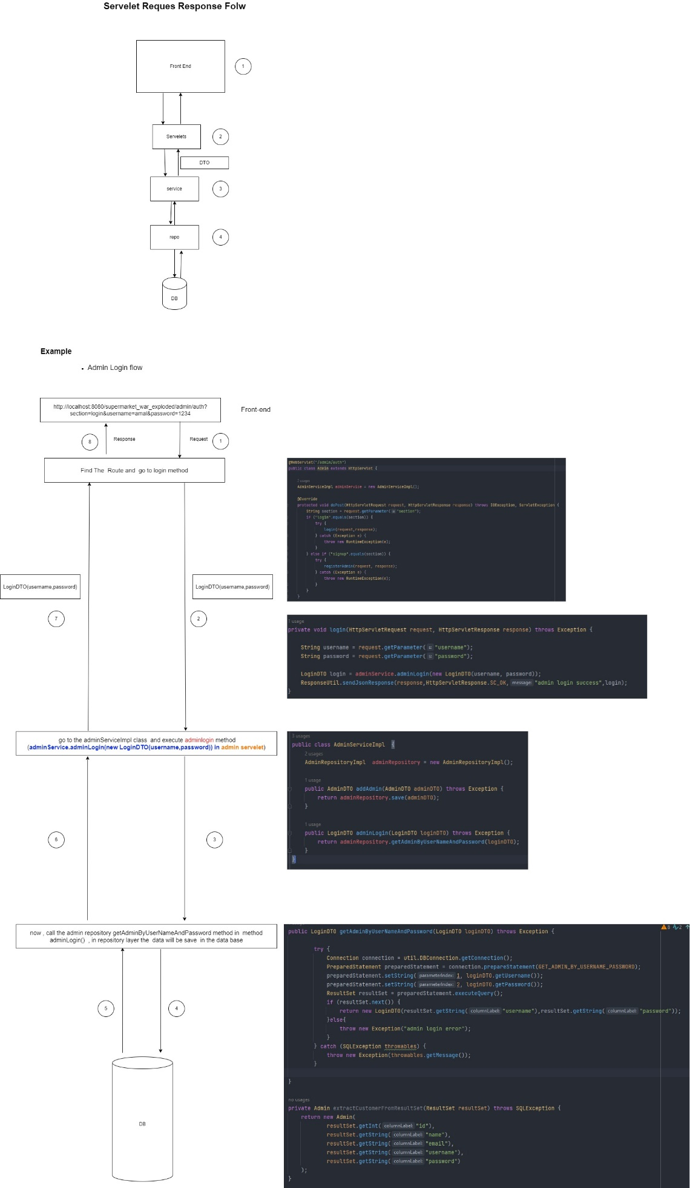

**Contribution Sheet**

|  |  |  |
| --- | --- | --- |
| **Student ID** | **Student Name** | **Contribution** |
| 28074 | K V V H Gunarathna | Programming Leader – Backend |
| 27114 | A M I S Senarathna | Documentation – Planning Leader |
| 28015 | A P H Abeysooriya | Backend |
| 27144 | I G S M Karunarathne | Documentation – Planning |
| 27809 | S P Welikada | Programming Leader - Frontend |
| 26181 | UGS Abhishek | Backend |